**Nutrition Assistant**

### 1 INTRODUCTION

**1.1 Description**

This project aims at building a web App that automatically estimates food attributes such as ingredients and nutritional value by classifying the input image of food. Our method employs Clarifai's AI-Driven Food Detection Model for accurate food identification and Food API's to give the nutritional value to the identified food.

**1.2 Purpose**

Nutrition today is a very big concern for all individuals. With the amount of junk food consumption the world is moving to a very unhealthy place. Nutritionists serve as guides to manage our diet and make sure we do not have an unhealthy lifestyle but not everybody can afford a personal nutritionist. This is where our app comes in, it is an inexpensive way to find out how much calorie you would be consuming and therefore manage it yourself. Not only this teaches discipline but also makes you healthy.

### 2 LITERATURE SURVEY

**2.1 Existing problem**

Similar kinds of applications available on the internet are text based. They return you nutritional values based on a text input such as food input but that does not reflect how much calories your food might have.

**2.2 Proposed solution**

Same food might have different calorific values for different ways of cooking. This application is however image based so it can understand more details. If you are not consuming the full dish but only a part of it you can upload the part of food you are consuming and it will return values for only the amount you are consuming. Thus image based nutrition management systems perform better.

### 3 THEORETICAL ANALYSIS

**3.1 Block diagram Diagrammatic overview of the project.**

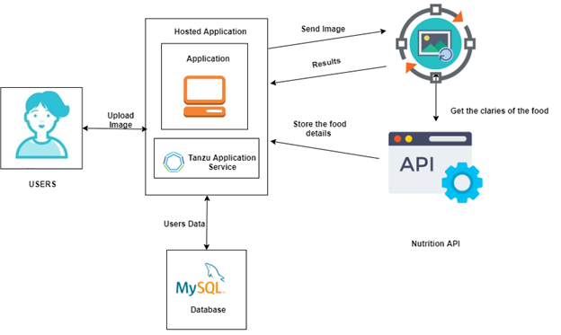

**3.2 Hardware / Software**

Hardware requirements: Working PC, internet connection

Software requirements: HTML, Bootstrap, MySQL, Springboot, Cloud Foundry, Tanzu Application Service, REST API's

**Project Description:**

### 4 EXPERIMENTAL INVESTIGATIONS

1. The user interacts with the Web App Loads an image.
2. The image is passed to the server application, which uses Clarifai's AI-Driven Food Detection Model Service to analyze the images and Nutrition API to provide nutritional information about the analyzed Image.
3. Nutritional information of the analyzed image is returned to the app for display.

### 5 ADVANTAGES & DISADVANTAGES

Advantages:

1. Provides better information on nutritional values by using visual recognition.
2. Can understand if a item is branded and then provide nutritional values of the specific brand
3. Can distinguish between different amount of servings

Disadvantage:

1. Can misclassify similar looking food
2. Can not determine specific ingredients from food items

### 6 CONCLUSION

This project has been a challenge that was fun to overcome. So many ideas incorporated into a single application makes up for a good challenge. The application is not 100% accurate as foods can look similar. The ingredients in the dishes cannot be distinguished in certain scenarios so the application is not able to predict correctly. Besides these constraints the application provides very good information.

### 7 FUTURE SCOPE

Enhancements that can be made in the future:

1. UI Improvement
2. Scaling the application to handle more requests
3. Building mobile app for mobile users.

### 8 BIBLIOGRAPHY

[1]<https://www.w3schools.com/html/> - W3schools html guide

[2]<https://www.w3schools.com/w3css/defaulT.asp> - W3schools CSS